Making a Carbon Cloth tube

These are just some notes and thoughts on what I learned doing this – I am far from an expert.

My tube needed to be 15” in diameter and app. 32” long. This stubby shape came about because my scope will be a three segment design. Longer tubes may necessitate different techniques.

To start out, I built a form on which to lay up the tube. If you could find sonotube the right diameter, you could use that as a form, but I was unable to find any in the diameter I needed.

I built the form on a center dowel rod. I used a closet rod, but if you will be making a longer tube you might need to use pipe. Just make sure it doesn’t sag. Support the rod on a couple of sawhorses with blocks screwed to them to make “V”s for the rod to rest and rotate in.

Cut out a number of discs from particle board to use as spacers. I used 6 discs, but should have used more. These can easily be cut on a band saw or with a router (messy). To do it on a bandsaw, make a board with a nail at the center point and slide it into the blade of the bandsaw at the radius point so the blade is passing through the board at the mark. Clamp it in place. Use a compass to draw the circles on the particle board and drill small holes of the same size as the nail in the centers. Rough cut the circles with a saber saw then use the band saw to cut them true. Drill out the centers to fit over the dowel.

To make it easy to get the form out of the tube, use a table saw (or router, or hand saw) to cut a cross shape on each disc like so:

Only cut halfway through.

You now mount these on the dowel at even intervals. They should be drilled so they slid on but stay in place. I then drove drywall screws into the dowel next to each disc on both sides lined up with the grooves. These hold the discs in place and act as breakers when removing the form.

You end up with something like this:

At this point you can do a couple of things. I chose a way that caused me some trouble, but I will describe it anyway as there is a simple fix to what I did.

I used hardware cloth with ¼” squares and wrapped the form in it. The mesh was attached using staples. Take care to make a smooth cylinder and attach it well and frequently tot eh discs. While doing this you can use the mesh to help make sure the discs are perpendicular to the rod and parallel with each other. Don’t overlap the ends – cut them so that they meet edge to edge. I uses some wire to stitch them at eh seem to keep them from sticking up.

An alternative would be to use lath strips across the discs to make the form more solid. I would still use the hardware cloth over that, though to make the tube round.

To avoid the mesh pattern form showing through, I wrapped the form in a layer of posterboard. Followed by a covering of thin plastic sheeting (plastic drop cloth works) to keep the resin from sticking. I stretched this as tightly as I could to make a smooth surface.

NOTE: remember when you make the discs that the total inner diameter measurement will be the diameter of the discs PLUS the thickness of the hardware cloth and any other layers you apply before laying up the carbon.

All this actually goes very quickly – just keep things as neat as you can. Note that if you can find a Sonotube the right size, all you need to do is stick in some spacers on a center rod and wrap it in plastic.

Applying the Cloth
I used pretty standard carbon cloth as sold at places like Tap Plastics. The material is 50” wide and since I was making a 34” long tube and my circumference was about 47”, one yard covered the whole thing neatly.

NOTE: standard weave carbon cloth unravels like an SOB when cut. To avoid this, use masking tape and cut down the middle of the tape. Allow overage so that the cut ends get disposed up in final trimming. Also if you want it to look nice, try hard to avoid snagging the cloth on anything or allowing it to get skewed. It is easy to end up with voids otherwise.

Draw a line on the form (or use masking tape) to use as an alignment aid, then
to make it simpler to put on the first layer, spray the entire form lightly with spray adhesive. This won’t affect the final product but keeps the cloth from drooping off as you apply the resin. Roll up the carbon cloth you cut to size and starting at the line, stick it to the form – this is easier with two people. If you get wrinkles, lift the cloth and smooth it out. Work all the way around the form. Use staples if necessary to hold it in place if the adhesive isn’t holding well enough. Get the layer very neatly laid on and smooth. At the seam, the best approach is to overlap by approximately ½”. Fray the end so that you have just the threads that wrap around the tube overlaying the starting point. These will get smoothed down when the resin is applied. I didn’t have to do a multiple piece covering for my tube, but I would assume that if you have to, this same technique would work. You can also just overlap the cloth and once the resin is partially cured, use a razor knife and a straightedge to cut through the seam and remove the excess so the edges butt neatly. This isn’t as strong, but if you stagger the seams by layer, it will be fine and looks neater too.

Once the cloth is in place, mix your resin according to the manufacturer instructions. I used a medium slow cure mixture to give me time to work the resin properly. Anything that sets up too fast can be a real problem. Cure time will be longer in a colder area as well.

To apply the resin, I used a roller made for resin – essentially just a paint roller made of tougher materials. Pour the resin in a disposable roller pan and go at it. You don’[t need a tone of resin – it will spread a lot more than you think it will when you start. The carbon cloth is rated by ounces of resin per yard needed to wet it out. This is usually around 5 Oz per square yard. Better to mix too much rather than too littler, but if you mix a lot and it is in a small container be careful to the heat generated by it as it cures.

Work around the tube until the first layer is totally wetted out. Then take a squeegee (I think that’s what they call them) made for the task, and work the resin into the cloth. Use long smooth strokes and work mainly around the circumference rather than the length. This will tend to keep wrinkling to a minimum. The purpose of the squeegee is to smooth things out, press the resin into the cloth, and to remove excess resin. Too much resin does nothing to add strength and only makes it heaver. Work until you are sure the entire tube is wet, smooth, and not too puddle with resin.

At the seam, use the squeegee to smooth out the frayed end where it laps over the start of the cloth. You should be able to make it very smooth here. If things start to set up as you work, back off and let it cure – it will just get ugly fast if things start sticking.

Here is where I screwed up – I then proceed to do the next two layers in a wet lay-up over the first layer. This was a mistake because my form wasn’t strong enough and it buckled and wrinkled in several places which caused me to have to do a bunch of work to fix it and which ended up adding weight. A better approach is to let the first layer cure most of the way before you start the next layer.

The second layer is Balltek mat. This is a glass fiber felt-like material embedded with microspheres. It adds a ton of stiffness to the tube without adding a ton of weight. If your first layer is a little tacky, you can use that to your advantage to hold the mat in place. Otherwise, go ahead and use the spray adhesive again. Wrap the mat so that its ends but up neatly to each other (or if you plan on using a pressure wrap to compress the layers, leave a gap so that the ends don’t rise up when the mat is squished). Staples work here too. Baltek uses a lot more resin than the carbon cloth, so you will need to mix more than before. Use a fresh container and roller cover and pan. Apply the resin with the roller until you think you have the whole thing wetted out. A good tool to use here is a grooved roller (they sell them at most fiberglass supply places). Use the grooved roller to really work the resin into the mat. You want it wet, but not sopping.

If you don’t mind a bit heavier tube, let this cure until slightly sticky and apply the outer layer of carbon cloth. If you want to save some weight, apply the outer layer right away. Either way, the application is the same as before. For the outer layer, you might consider a Carbon Twill – it looks nicer and adds a little strength.

If you are looking to save weight you will need to compress the layup with some special layers to absorb the excess resin. This is where my tube got wrinkled, so I make no guarantees. It should be OK as long as your first layer is solid, but you may want to avoid this if you aren’t totally sure about it. The way I did this is to wrap the laid up form in a material called Peel-ply. This is essentially Dacron treated so it won’t stick to Epoxy resin. You then wrap that in a layer of batting (sometimes called a bleeder layer). Then I wrapped the whole mess in multiple layers of that stretchy plastic used for securing stuff to palettes. This last layer was stretched tightly as I wrapped and it put considerable pressure on the form. This forces the resin through the peel-ply and into the batting. This makes the resulting composite strong but light since there is no excess resin in it. It also gives a slightly rough matte finish. This is essentially the same as a vacuum bag technique, but without the vacuum. If you have access to vacuum equipment, I would recommend that instead. Finally, if you really don’t want to worry about it, blow off the pressure wrap and just lay it up as neatly as you can and don’t worry about the few extra ounces of resin.

Removing the Form
This is the fun part. After everything has cured (let it go a couple of days – and if your work area is chilly, consider a space heater directed in the general direction of the form). Peel off the outer wrap if you used one. Take the form and pick it up and slam one end of the dowel hard on the floor. The screws should break through the discs allowing the entire dowel and disc assembly to be removed. The hardware cloth, cardboard and plastic wrap all should peel out easily as well. Watch out for rogue staples as they can be nasty sharp things. You can either pull the staples through the tube with a pair of pliers or simply cut them off flush. Once all the garbage is removed, trim the tube to length, give it a light sanding with 220 grit and apply a couple of coats of a good polyurethane UV resistant varnish. The interior will be somewhat irregular and shiny and I recommend lining it with something to cover it up (I used black velvet). Or sand it with coarse sand paper and spray it black.

The strength, light weight and rigidity of a three layer tube like this is remarkable. Depending on your use, you might want to reinforce the ends of the tube some, but the stuff is pretty tough.

Fixing my screw-ups
As I said above, I ended up with some ugly large wrinkles and buckles from the pressure wrapping process. I used micro-spheres in resin to make a filler compound and fill in as well as I could. This all got sanded and I ended up applying an outer wrap of carbon twill to cover this all up. I could have just painted it, but I wanted the carbon cloth look. Thus the effort to save a few ounces of weight cost me the added weight of the compound plus the extra layer of cloth and resin.

Below are a couple of snapshots of the process:

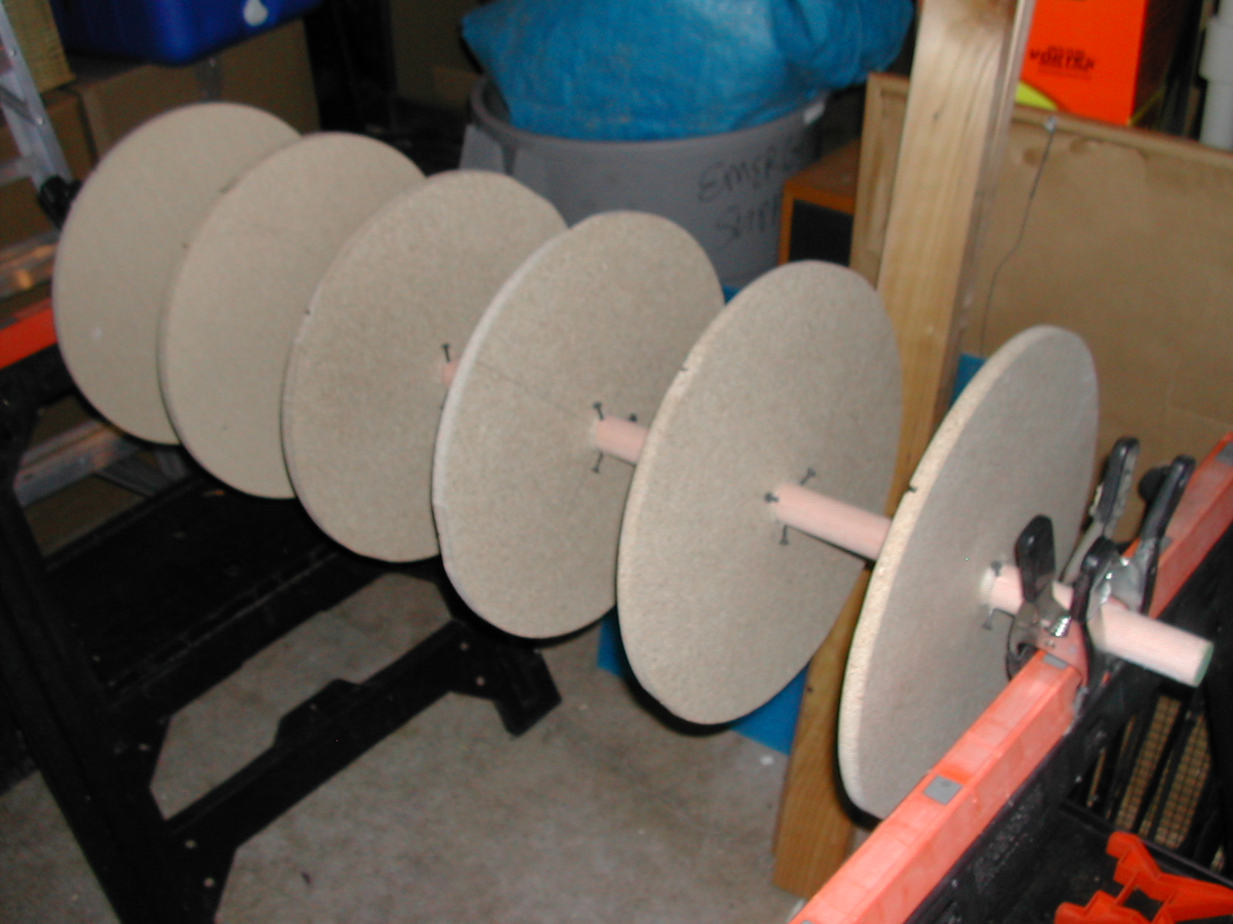
The discs and rod – needed more discs!

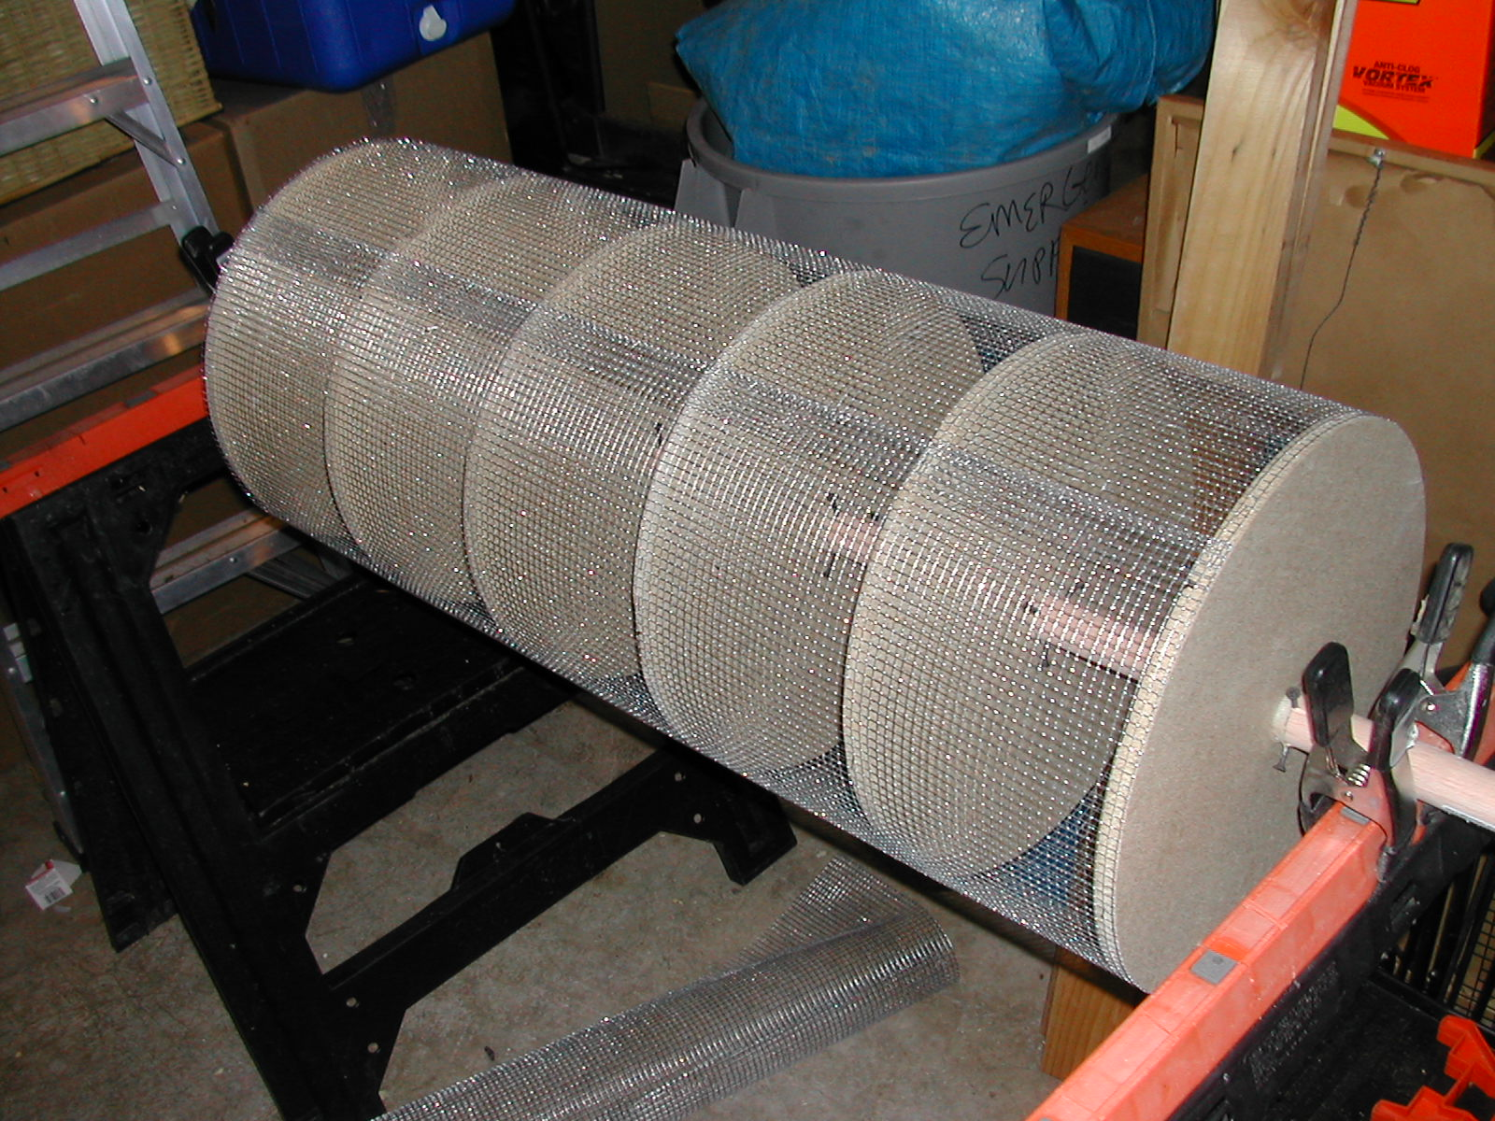
Hardware Cloth applied

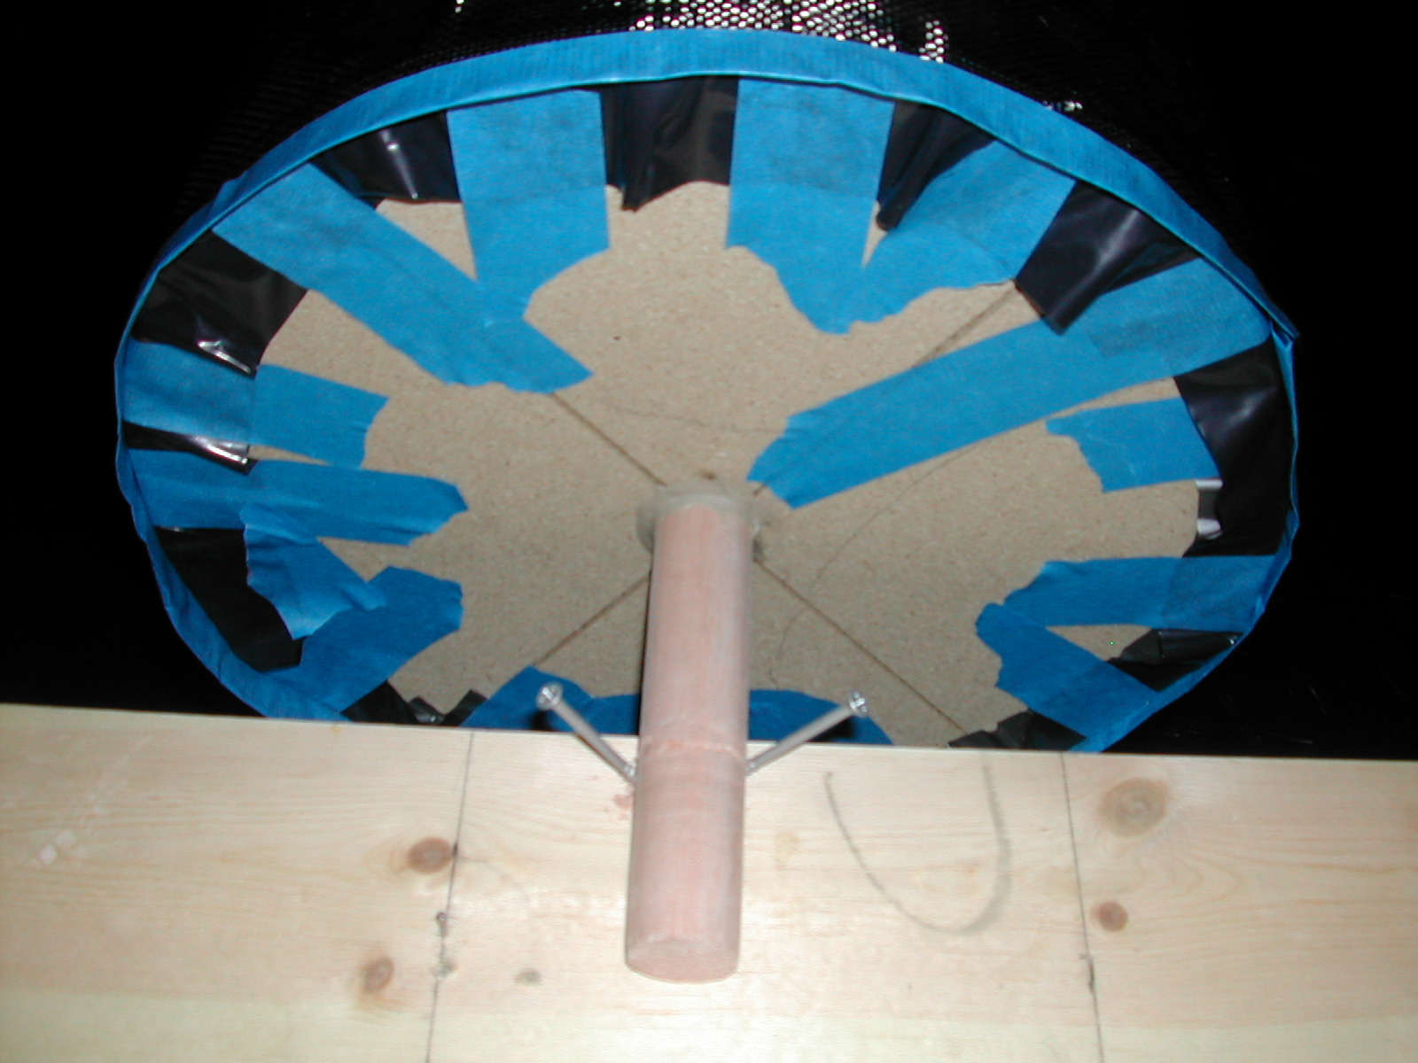
The end showing detail of a disc

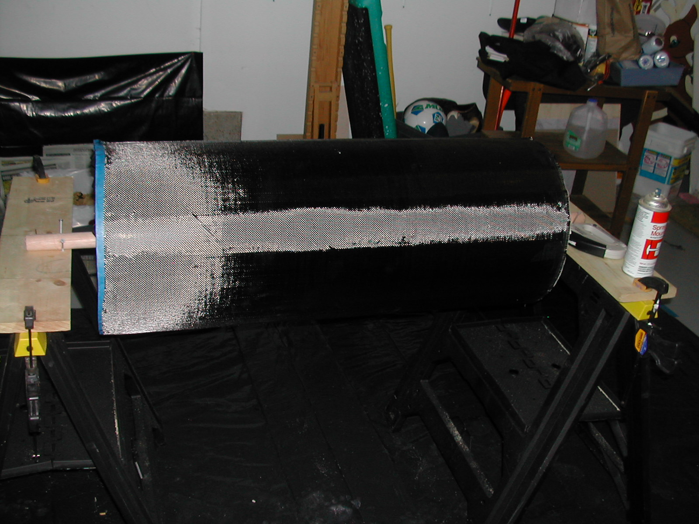
First layer before wetting out
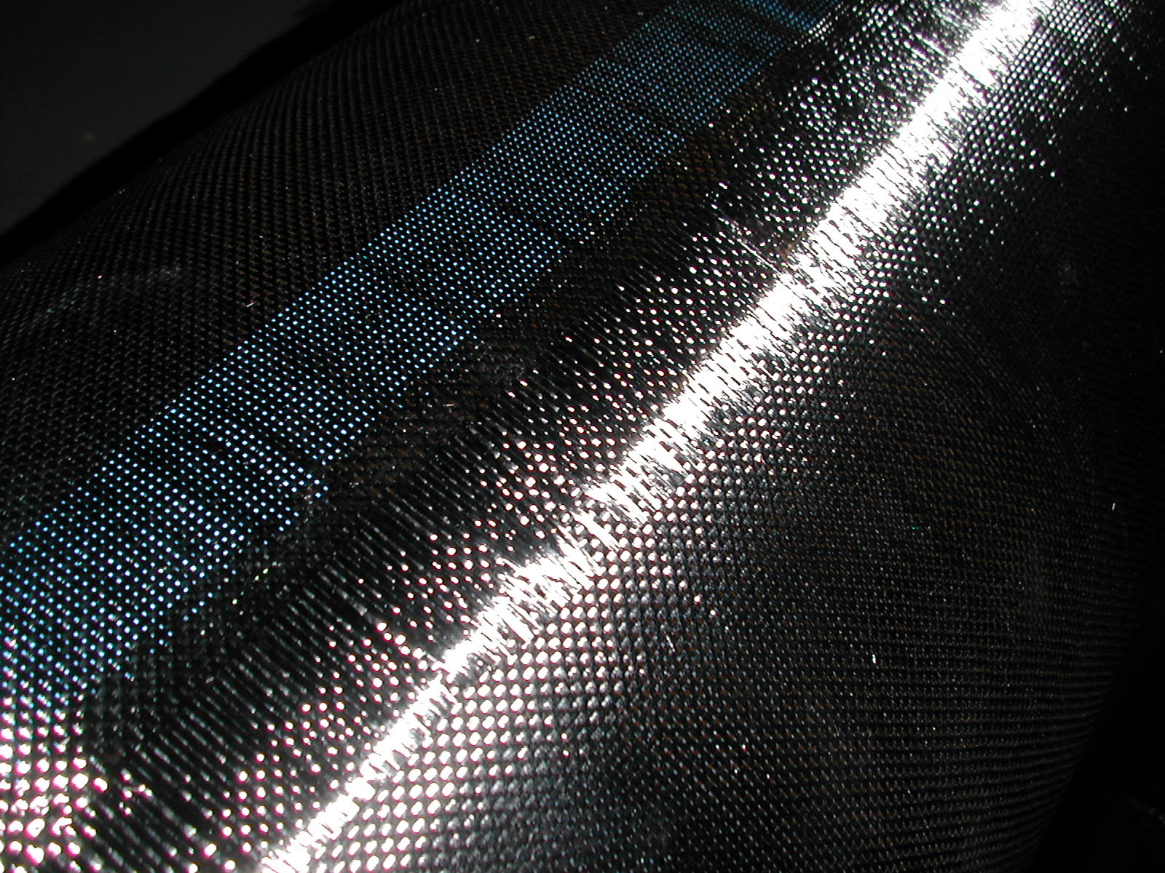
Close up showing the overlapped edge

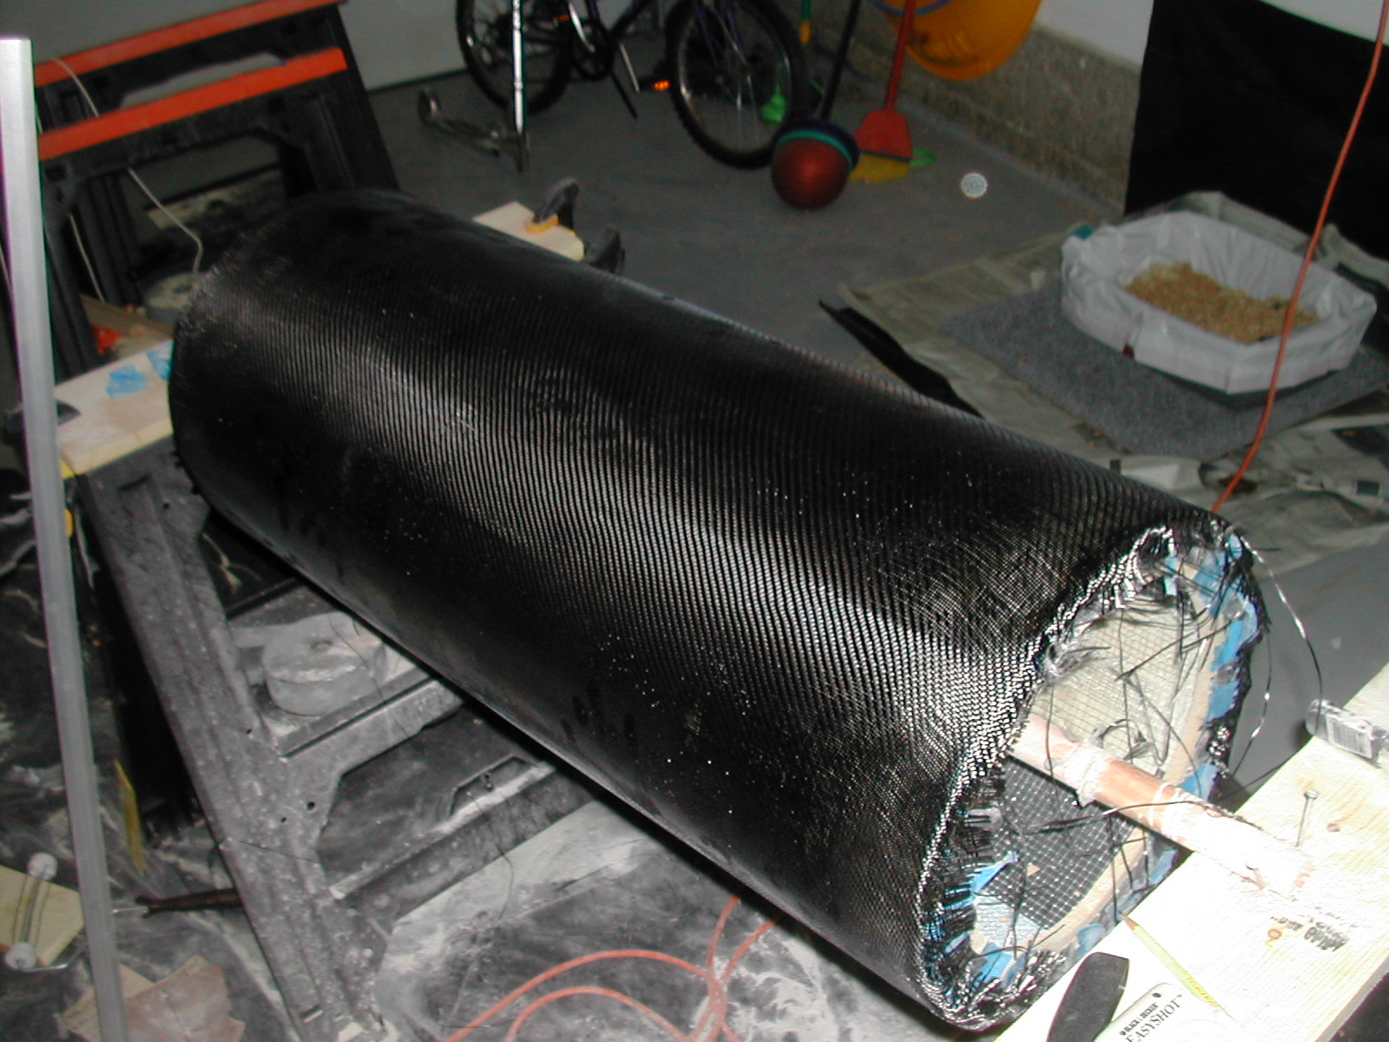
Outer layer of twill applied
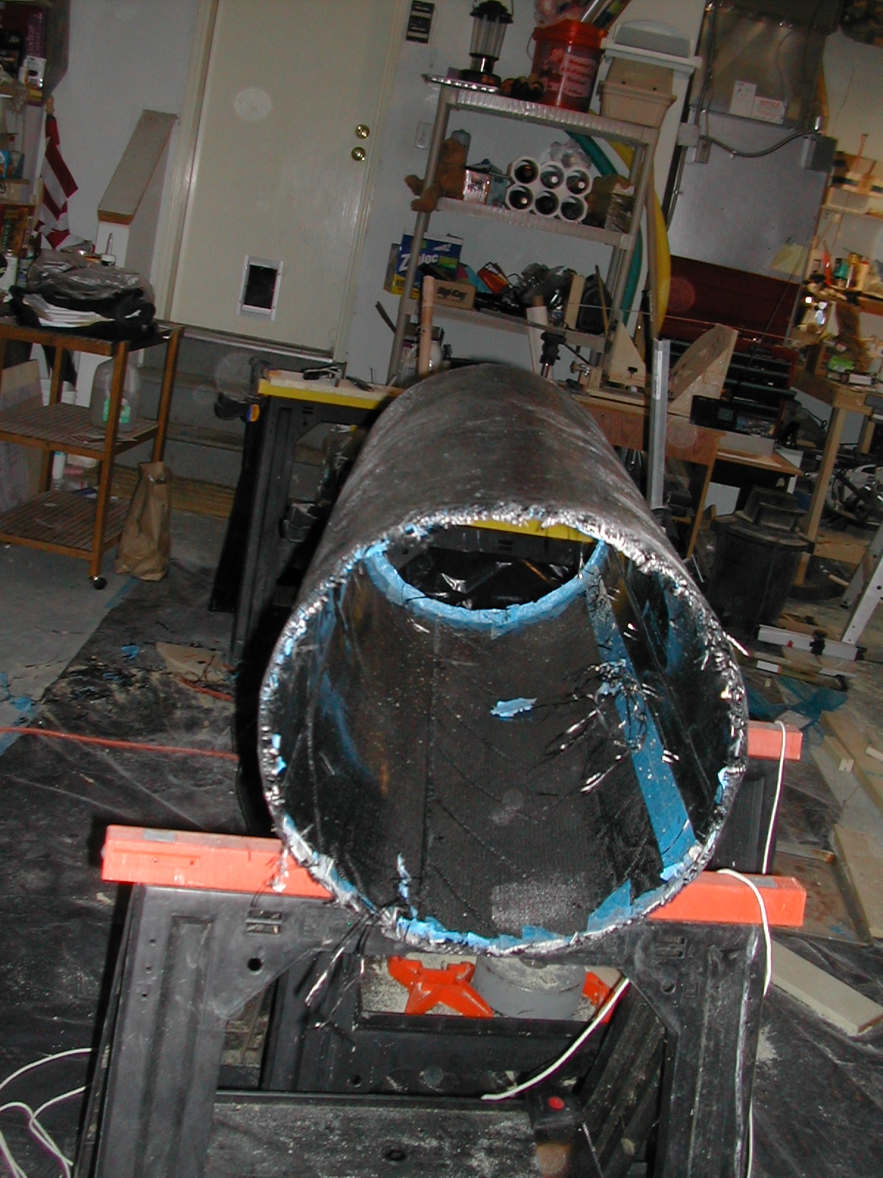
Just removed the form. Ugly, huh?

2 nearly finished tube sections – the left lined with velvet, the other just painted.
